CISCO NETWORKING PROJECT
Project 1: Static Routing
Multi-Router Static Route Configuration and Verification using Cisco Packet Tracer
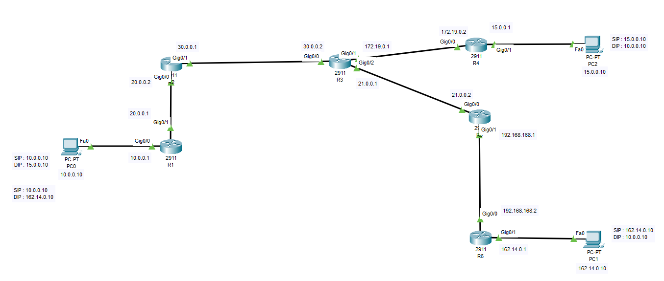
Figure — Full Network Topology (6 Routers, 3 Hosts)
Routers | R1 – R6 (Cisco 2911)
Routing Method | Static Routes
End Devices | PC0, PC1, PC2
Simulation Tool | Cisco Packet Tracer

1. Project Objective
This project demonstrates end-to-end IP reachability across a six-router Cisco network using static routing. The network consists of eight distinct network IDs, and the goal is to ensure every router holds a complete route to all eight networks so that traffic can be exchanged between the three end hosts (PC0, PC1, and PC2).
The task involves the following stages, in order:
- Record all IP networks shown in the topology and assign interface addressing to each router.
- Bring up directly connected routes by activating each router interface.
- Verify reachability router‑by‑router and identify any missing routes.
- Configure static routes to fill the gaps and confirm end‑to‑end connectivity with ping tests.

1.1 Network IDs in the Topology
A total of eight networks must be present in every router's routing table for full reachability:
1. 10.0.0.0 /8 | 2. 15.0.0.0 /8
3. 20.0.0.0 /8 | 4. 21.0.0.0 /8
5. 30.0.0.0 /8 | 6. 162.0.0.0 /8
7. 172.0.0.0 /8 (172.19.0.0 /16 used) | 8. 192.0.0.0 /8 (192.168.168.0 /24 used)

2. Network Topology
The topology consists of six routers connected in a linear/branching backbone, with end-user hosts attached at the far edges. PC0 (10.0.0.10) sits behind R1; PC2 (15.0.0.10) sits behind R4; PC1 (162.14.0.10) sits behind R6.

Figure 1 — Network topology as built in Cisco Packet Tracer

3. IP Addressing Plan
Once the networks were identified, each router interface was assigned an IP address matching the topology diagram. Assigning the interface addresses automatically creates the corresponding directly-connected routes in each router's routing table.

3.1 Router Interface Addressing
Router | Interface | IP Address | Prefix | Purpose
R1 | GigabitEthernet0/0 | 10.0.0.1 | /8 | LAN link to PC0
R1 | GigabitEthernet0/1 | 20.0.0.1 | /8 | Link to R2
R2 | GigabitEthernet0/0 | 20.0.0.2 | /8 | Link to R1
R2 | GigabitEthernet0/1 | 30.0.0.1 | /8 | Link to R3
R3 | GigabitEthernet0/0 | 30.0.0.2 | /8 | Link to R2
R3 | GigabitEthernet0/1 | 172.19.0.1 | /16 | Link to R4
R3 | GigabitEthernet0/2 | 21.0.0.1 | /8 | Link to R5
R4 | GigabitEthernet0/0 | 172.19.0.2 | /16 | Link to R3
R4 | GigabitEthernet0/1 | 15.0.0.1 | /8 | LAN link to PC2
R5 | GigabitEthernet0/0 | 21.0.0.2 | /8 | Link to R3
R5 | GigabitEthernet0/1 | 192.168.168.1 | /24 | Link to R6
R6 | GigabitEthernet0/0 | 192.168.168.2 | /24 | Link to R5
R6 | GigabitEthernet0/1 | 162.14.0.1 | /16 | LAN link to PC1

3.2 End-Device (PC) Addressing
Host | IP Address | Subnet Mask | Default Gateway | Connected To
PC0 | 10.0.0.10 | 255.0.0.0 | 10.0.0.1 | R1 Gig0/0 LAN
PC2 | 15.0.0.10 | 255.0.0.0 | 15.0.0.1 | R4 Gig0/1 LAN
PC1 | 162.14.0.10 | 255.255.0.0 | 162.14.0.1 | R6 Gig0/1 LAN

4. Baseline Interface Configuration
Before configuration, all router interfaces are administratively down with no IP address assigned, as shown by show ip interface brief on R1:
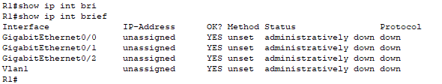
Figure 2 — show ip interface brief before configuration (R1)
Each interface was then configured with its IP address and enabled with no shutdown. Example configuration on R1:
R1#configure terminal
R1(config)#interface gig0/0
R1(config-if)#ip address 10.0.0.1 255.0.0.0
R1(config-if)#no shutdown
%LINK-5-CHANGED: Interface GigabitEthernet0/0, changed state to up
%LINEPROTO-5-UPDOWN: Line protocol on Interface GigabitEthernet0/0, changed state to up
R1(config-if)#exit
R1(config)#interface gig0/1
R1(config-if)#ip address 20.0.0.1 255.0.0.0
R1(config-if)#no shutdown

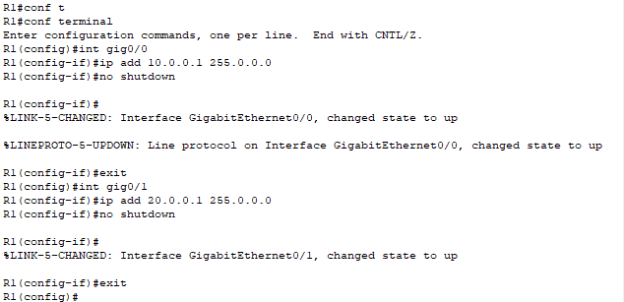
Figure 3 — Interface configuration commands entered on R1
The same ip address / no shutdown sequence was repeated on every interface of R2, R3, R4, R5 and R6 using the addressing plan in Section 3.

5. Verifying Directly Connected Routes
After configuring R1 only, Gig0/1 shows protocol down, because the neighboring router (R2) has not yet been configured — there is no device on the other end of the link to complete the up/up state.
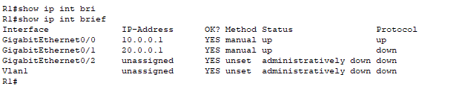
Figure 4 — show ip interface brief: Gig0/1 protocol down before R2 is configured
Consequently, the 20.0.0.0/8 network is missing from R1's routing table, because a Cisco router only installs a connected route once the interface line protocol is up.
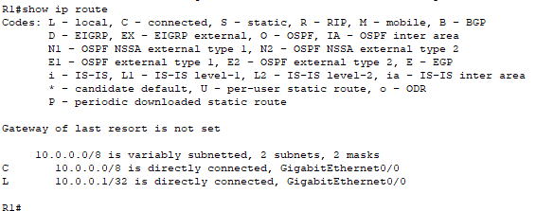
Figure 5 — show ip route: 20.0.0.0 network absent until the R2 link comes up
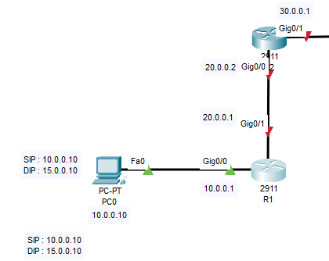
Figure 6 — Detail: link between R1 and R2 shown down in the topology
Once R2's matching interface (Gig0/0, 20.0.0.2) is configured and enabled, the link comes up and the 20.0.0.0/8 network appears automatically in R1's route table as a directly connected (C) route.
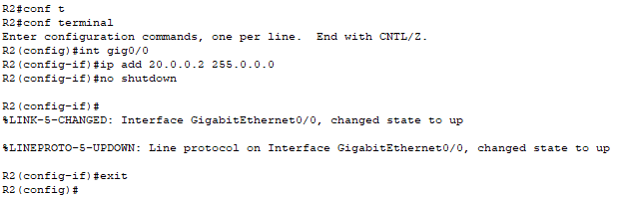
Figure 7 — R2 interfaces after configuration
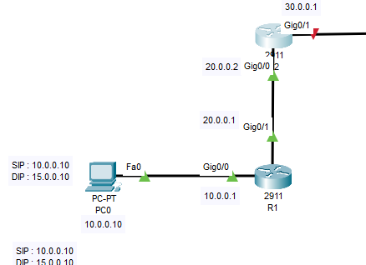
Figure 8 — Link state up between R1 and R2
R1's routing table now shows the 20.0.0.0/8 network automatically, confirming the directly connected route was installed:
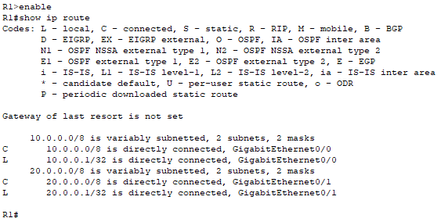
Figure 9 — show ip route on R1: 20.0.0.0/8 now present
This same process — assign IP address, enable the interface, verify the link and the connected route — was repeated for every remaining interface on R2, R3, R4, R5 and R6 until all directly connected networks matched the addressing plan in Section 3.

6. Identifying Missing (Non-Connected) Routes
With all interfaces up, each router only knows about the networks it is directly connected to. Networks that are more than one hop away are still missing and must be reached with static routes. End devices were assigned IP addressing on their NICs matching the plan in Section 3.2, and a ping test was run between PC0 and PC2 to confirm whether reachability already exists.
Testing connectivity between PC0 (10.0.0.10) and PC2 (15.0.0.10) fails, since none of the intermediate routers has a route to the remote network yet — this confirms static routes are required.
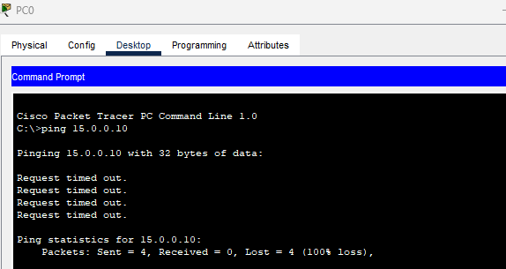
Figure 10 — Ping from PC0 (10.0.0.10) to PC2 (15.0.0.10) times out before static routes exist
Path 10.0.0.10 → 15.0.0.10 requires static routes on R1, R2 and R3 pointing toward the 15.0.0.0/8 network (R4 is directly connected to it). The return path 15.0.0.10 → 10.0.0.10 requires static routes on R4, R3 and R2 pointing back toward 10.0.0.0/8 (R1 is directly connected to it).

7. Static Route Configuration
Static routes were added with the ip route command in the form: ip route <destination network> <subnet mask> <next-hop IP>.

7.1 Path: PC0 (10.0.0.10) ↔ PC2 (15.0.0.10)
Forward direction — routing toward 15.0.0.0/8
Router | Configuration
R1 | ip route 15.0.0.0 255.0.0.0 20.0.0.2
R2 | ip route 15.0.0.0 255.0.0.0 30.0.0.2
R3 | ip route 15.0.0.0 255.0.0.0 172.19.0.2
R4 | Directly connected to 15.0.0.0/8 — no static route needed
The command below shows the route being added on R1, and the resulting routing table with the new static (S) entry for 15.0.0.0/8 via 20.0.0.2:
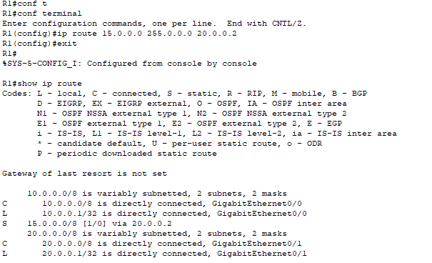
Figure 11 — R1: ip route 15.0.0.0 255.0.0.0 20.0.0.2 configured; show ip route confirms the new S route
Return direction — routing toward 10.0.0.0/8
Router | Configuration
R4 | ip route 10.0.0.0 255.0.0.0 172.19.0.1
R3 | ip route 10.0.0.0 255.0.0.0 30.0.0.1
R2 | ip route 10.0.0.0 255.0.0.0 20.0.0.1
R1 | Directly connected to 10.0.0.0/8 — no static route needed
Before the return-path routes are added, PC2 can already reach as far as R4, but the reply is rejected further upstream ('Destination host unreachable' from 15.0.0.1) because R4 does not yet know how to route back to 10.0.0.0/8:
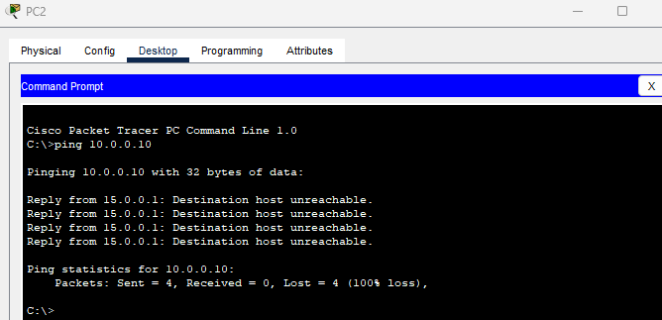
Figure 12 — Return path from PC2 (15.0.0.10) still failing until R4, R3 and R2 get their static route back to 10.0.0.0/8
Once the return-path static routes above are added, verification confirms full success — ping from PC0 to PC2 now succeeds:
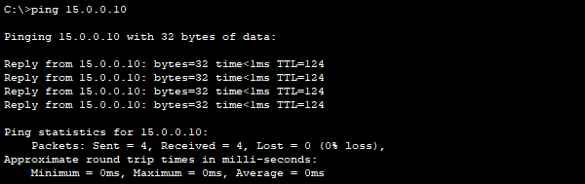
Figure 13 — Successful ping: 10.0.0.10 → 15.0.0.10 (0% loss)

7.2 Path: PC0 (10.0.0.10) ↔ PC1 (162.14.0.10)
Forward direction — routing toward 162.0.0.0/8
Router | Configuration
R1 | ip route 162.0.0.0 255.0.0.0 20.0.0.2
R2 | ip route 162.0.0.0 255.0.0.0 30.0.0.2
R3 | ip route 162.0.0.0 255.0.0.0 21.0.0.2
R5 | ip route 162.0.0.0 255.0.0.0 192.168.168.2
R6 | Directly connected to 162.0.0.0/8 — no static route needed
Return direction — routing toward 10.0.0.0/8
Router | Configuration
R6 | ip route 10.0.0.0 255.0.0.0 192.168.168.1
R5 | ip route 10.0.0.0 255.0.0.0 21.0.0.1
R3 | Route to 10.0.0.0/8 already exists (added in Section 7.1)
R2 | Route to 10.0.0.0/8 already exists (added in Section 7.1)
R1 | Directly connected to 10.0.0.0/8 — no static route needed
With all static routes in place, every host can now reach every other host across the topology:
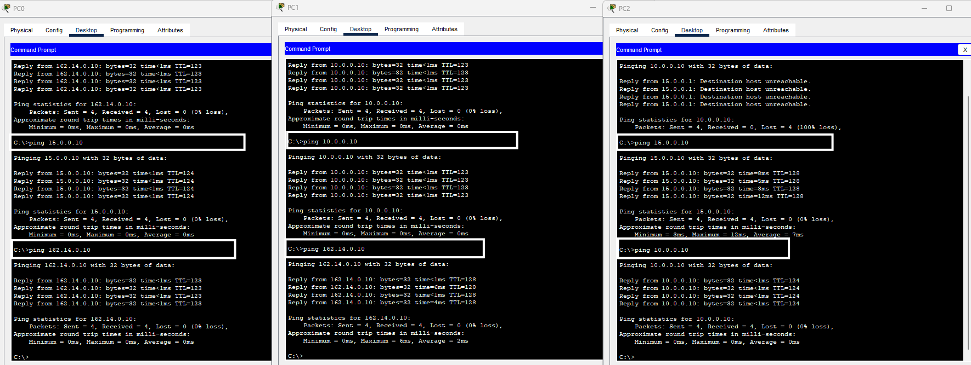
Figure 14 — Full topology after configuration: all links up, static routes installed, end-to-end ping successful

8. End-to-End Path Summary

8.1 PC0 (10.0.0.10) → PC2 (15.0.0.10)
PC0 → R1 → R2 → R3 → R4 → PC2

8.2 PC0 (10.0.0.10) → PC1 (162.14.0.10)
PC0 → R1 → R2 → R3 → R5 → R6 → PC1

9. Conclusion
All eight required networks were successfully installed into the routing table of every router, using a combination of directly connected routes (from interface addressing) and manually configured static routes. Ping tests confirmed full, bidirectional reachability between PC0, PC1 and PC2 across all six routers, meeting the project objective.
Key takeaways from this exercise:
- A directly connected route only appears once both ends of a link are configured and the line protocol is up.
- Static routes must be configured in both directions — the forward path and the return path each need their own route on every intermediate router.
- A router that already carries a route to a network from an earlier task (e.g. R2/R3 already routing to 10.0.0.0/8) does not need that route re-added for a new destination.
- show ip interface brief and show ip route are the primary tools for diagnosing missing connectivity before and after static route configuration.

